50. What is K-map and its advantages?

Ans. The K-map simplification technique is simpler and less error-prone compared to the method of solving the logical expressions using Boolean laws.

Advantages :-

1.Minimizes boolean expressions without the need using various boolean theorems & computations.

2.Minimizes number of Logical gates used.

51. What is the difference between SOP and POS?

Ans.

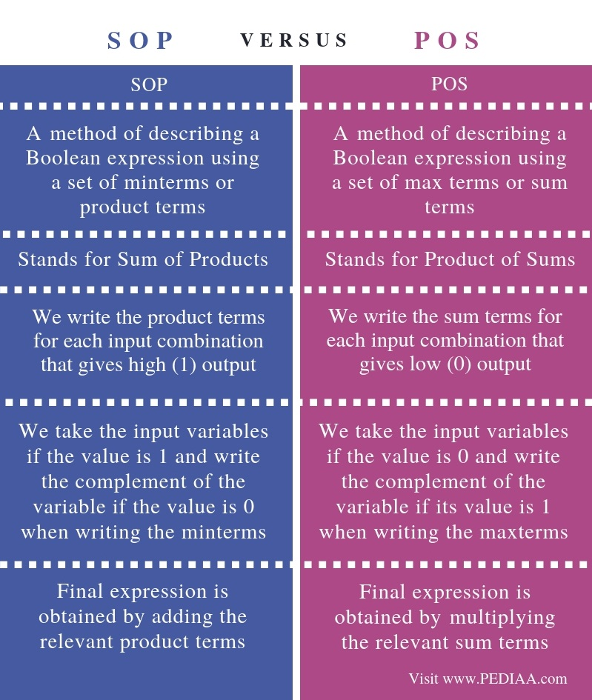

52. Which code is used in K map?

Ans. Gray Code

53. Who introduced K map?

Ans. Maurice Karnaugh

54. What are some applications of set theory in the real world?

Ans. Formulating logical foundation for geometry , calculus , and topology to creating algebra revolving around field, rings and groups .

55. Find the simplified expression A’BC’+AC’ .

Ans.  (A+B)C’

56. Simplify the expression: A’(A + BC) + (AC + B’C).

Ans. (a’b+c’)

57. Simplify the expression XZ’ + (Y + Y’Z) + XY

Ans. x + y + z

58. Find the simplified term Y’ (X’ + Y’) (X + X’Y)?

Ans. x y’

59. Minimize the following Boolean expression using Boolean identities.

Ans.

60. What is the value of x after this statement, assuming the initial value of x is 5? ‘If x equals to one then x=x+2 else x=0’.

Ans. 0

61. The binary relation {(1,1), (2,1), (2,2), (2,3), (2,4), (3,1), (3,2)} on the set {1, 2, 3} satisfies which characteristics .

Ans. Transitive

62. Consider the binary relation, A = {( a , b ) | b = a – 1 and a, b belong to {1, 2, 3}}. The reflexive transitive closure of A is?

Ans. {( a , b ) | a >= b and a, b belong to {1, 2, 3}}

63. Determine the characteristics of the relation a R b if a2 = b2.

Ans. symmetric, reflexive and transitive

64. say true or false

Relations may exist between?

A. objects of the same set

Ans. True

B. between objects of two or more sets

Ans. True

65. For two distinct sets, A and B, having cardinalities m and n respectively, the maximum cardinality of a relation R from A to B is ?

Ans. 2mn

66. A relation can be represented using which graph?

Ans. Directed Graph

67. A relation R on set A is called _________ if xRy implies yRx.

Ans . Symmetric

68. The relation R={(a,b),(b,a)} on set X={a,b} is?

Ans. Irreflexive

69. If x ∈ N and x is prime, then x is ________ set.

Ans. Infinite Set

70. If x is a set and the set contains the real number between 1 and 2, then the set is __

Ans. Infinite Set

71. Convert the set x in roster form if set x contains the positive prime number, which divides 72

Ans . {2, 3}

72. Power set of empty or Null set has exactly _________ subset.

Ans . 1 i.e. { Φ }

73. What is the Cartesian product of set A and set B, if the set A = {1, 2} and set B = {a, b}?

Ans. {(1,a),(1,b),(2,a),(2,b)}

74. The members of the set S = {x | x is the square of an integer and x < 100} is ________________

Ans. { 0, 1 , 4 , 9 , 16 , 25 , 36 , 49 , 64 , 81 }

75. The intersection of the sets {1, 2, 8, 9, 10, 5} and {1, 2, 6, 10, 12, 15} is the set _______

Ans. { 1, 2, 10 }

76. The difference of {1, 2, 3, 6, 8} and {1, 2, 5, 6} is the set _________

Ans. { 3, 8 }

77. If n(A) = 20 and n(B) = 30 and n(A U B) = 40 then n(A ∩ B) is?

Ans. 10

78. Let the players who play cricket be 12, the ones who play football 10, those who play only cricket are 6, then the number of players who play only football are ___________, assuming there is a total of 16 players.

Ans . 4

79 The cardinality of the Power set of the set {1, 5, 6} is__________

Ans. 8

80 The Cartesian product of the (Set Y) x (Set X) is equal to the Cartesian product of (Set X) x (Set Y) or Not?

Ans. NO

81 How many elements in the Power set of set A= {{Φ}, {Φ, {Φ}}}?

Ans. 4

82 The number of reflexive closure of the relation {(0,1), (1,1), (1,3), (2,1), (2,2), (3,0)} on the set {0, 1, 2, 3} is________.

Ans. 6

83 The number of transitive closure exists in the relation R = {(0,1), (1,2), (2,2), (3,4), (5,3), (5,4)} where {1, 2, 3, 4, 5} ∈ A is__________.

Ans. 7

84 Canonical forms for a boolean expression has _______ types

Ans. 2 ( SOP or POS )

85 Boolean algebra deals with how many values.

Ans. 2 ( False(0) or True(1) )

86 Let A and B be two non-empty relations on a set S.

the statements is true or false

A and B are transitive ⇒ A∪B is not transitive

Ans. True

87 Let A and B be two non-empty relations on a set S.

the statements is true or false

A and B are transitive ⇒ A∩B is transitive

Ans. False

88 Let A and B be two non-empty relations on a set S.

the statements is true or false

A and B are symmetric ⇒ A∪B is symmetric

Ans. False

89 Let A and B be two non-empty relations on a set S. the statements is true or false A and B are reflexive ⇒ A∩B is reflexive

Ans. False

90 Let a set S = {2, 4, 8, 16, 32} and <= be the partial order defined by S <= R if a divides b. Number of edges in the Hasse diagram of is ______

Ans. 5

91 Suppose a relation R = {(3, 3), (5, 5), (5, 3), (5, 5), (6, 6)} on S = {3, 5, 6}. Here R is known as ______

Ans. equivalence relation

92 Determine the number of equivalence classes that can be described by the set {2, 4, 5}.

Ans. 5

93 Minimize the following Boolean Expression f(A, B, C) = AB' C+A' BC+AB+A' B' C

Ans. a(b’ + c)

94 Minimize the following Boolean Expression using k-map : f(A, B) = A' B+BA

Ans. B

95 Minimize the following Boolean Expression using k-map : AB + A' B+BA'

Ans. B

96 Write the dual of Boolean expressions:(x1*x2) + (x1*x3')

Ans.

97 Write the dual of Boolean expressions:(1+x2)*( x1+1)

Ans.

98 Write the dual of Boolean expressions: (a ∧(b∧c))

Ans.

99 If a set has n elements, how many relations are there from A to A.

Ans. 2n2  ( 2 to the power n2 )

100 If A has m elements and B has n elements. How many relations are there from A to B and vice versa?

Ans. 2m*n

**UNIT – III**

1.Which property must be satisfied for a set to be algebraic structure?

Ans- A non empty set A is called algebraic structure with respect to a binary operation if a*b €A for all values of a,b €A.

1. Which property must be satisfied for a set to be a semi group?

Ans- An algebraic structure (A,*) is called semi group if it follows the associative property. (a*b)*c=a*(b*c) for all values of a,b,c belongs to A. Here * is a binary operation.

1. Which properties must be satisfied for a set to be a monoid?

Ans- If an algebraic structure satisfies the associativity and if their exist an identity element (e). That is a*e=a.

For example a*1=a. and a+0=a

1. Which property must be satisfied for a set to be a group?

Ans- (A,*) is a group if • A is closed.

* + A is associative.
  + Their exists an identity element(e).
  + Their must be inverse of each element that is a*a^-1=e.

1. Which property must be satisfied for a set to be an abelian group?

Ans- Set is an abelian group we must satisfy the following five properties that is Closure Property, Associative Property, Identity Property, Inverse Property, and Commutative Property.

1. if a set satisfies only Closure property it is called Ans- Algebraic Structure.

1. if a set satisfies Closure and associative property it is called Ans- Semi group.

1. if a set satisfies Closure, Associative and Identity property it is called Ans- Monoid.

1. if a set satisfies Closure, Associative, Identity and inverse property it is called Ans- Group.

1. Name the 5 properties for a set to be abelian group

Ans- Closure Property, Associative Property, Identity Property, Inverse Property, and Commutative Property.

1. What is identity property?

Ans- An identity property is a property that applies to a group of numbers in the form of a set. It is named identity property because when applied to a number, the number keeps its ‘identity.’

1. What is inverse property?

Ans- Consider a non-empty set A, and a binary operation * on A. Then the operation is the inverse property, if for each a A,,there exists an element b in A such that a * b (right inverse) = b * a (left inverse) = e, where b is called an inverse of a and e is an identity element.

1. What is closure property?

Ans- In a set A if a*b €A for all values of a,b €A. Then set A satisfies the closure property.

1. What is associative property?

Ans- If in a set A if (a*b)*c=a*(b*c) for all values of a,b,c belongs to A. Then it satisfies the associativity property Here * is a binary operation.

1. A monoid is called a group if _______

Ans- A monoid(B,*) is called Group if to each element there exists an element c such that (a*c)=(c*a)=e. Here e is called an identity element and c is defined as the inverse of the corresponding element.

1. A group (M,*) is said to be abelian if ___________ Ans- If it satisfies the commutative property that is x*y=y*x.

1. What is commutative property?

Ans- For a set A if x*y=y*x then A satisfies the commutative property. Where x,y belongs to A.

1. A cyclic group is always ________

Ans- A cyclic group is always an abelian group.

1. a*H=H*a relation holds if

Ans- H is **subgroup of an abelian group.**

1. a*H is a set of which coset?

Ans- (a * H) is the set of **a left coset of H in G** .

1. What is generator in cyclic group?

Ans- In a set A there is an **element g**, such that every other element of the group can be written as a power of g. This element g is the generator of the group.

1. What is cyclic group?

Ans- A group where there exist a generator is called a cyclic group.

1. What is ring?

Ans- An algebraic structure (A,+,*) is said to be a ring if:

* + (A,+) should be an abelian group.
  + (A,*) should be monoid.
  + (*)should be distributive over first operation(+).

1. What is field?

Ans- An algebraic structure (A,+,*) is said to be a field if:

(A,+) should be abelian group.

(A,*)-(e) is an abelian group.

1. What are the conditions for a group to be a ring?

Ans-

* + (A,+) should be an abelian group.
  + (A,*) should be monoid.
  + (*)should be distributive over first operation(+).

1. What is subgroup?

Ans-A subgroup is a subset of group elements of a group. that satisfies the four group requirements. It must therefore contain the identity element.

1. eH=He=H, True or false

Ans-

1. No of elements in coset are( order of subgroup)

Ans- Number of elements in coset is equal to number of elements in subgroup from which coset is generated.

1. What is order of element?

Ans- The order of an element in a group is the smallest positive power of the element which gives you the identity element.

1. What is the order of an identity element?

Ans- By definition, the order of the identity, **e, is one**, since e 1 = e.

1. What is Semi group?

Ans- An algebraic structure (A,*) is called semi group if it follows the associative property. (a*b)*c=a*(b*c) for all values of a,b,c belongs to A. Here * is a binary operation.

1. What are the properties that are to be satisfied by a relation to be an ablien group?

Ans- Set is an abelian group we must satisfy the following five properties that is Closure Property, Associative Property, Identity Property, Inverse Property, and Commutative Property.

1. Is it compulsorry for an ablien group to be reflexive or not ?

Ans- To satisfy the closure property abelian group must be reflexive.

1. Is a set of integer along with + operator i.e. (Z,+) satisfies all the properties required for an ablien group or not ?

Ans- Yes, it satisfies the all properties of abelian group.

1. When we call a ring as a ring with 0 divisor?

Ans- A ring R is said to be a ring with zero divisors if there exist a,b belongs to R such that a≠0 and b≠0 yet a.b=0

1. Define a Ring .

Ans- An algebraic structure (A,+,*) is said to be a ring if:

* + (A,+) should be an abelian group.
  + (A,*) should be monoid.
  + (*)should be distributive over first operation(+).

1. A non empty set is said to be an algebraic structure with respect to unary , binary , ternary which type of operation.

Ans- A non empty set A is called an algebraic structure w.r.t binary operation.

1. Which type of property does matrix multiplication holds?

Ans- Associative property of multiplication-> A.(BC)=(AB).C

Distributive property of multiplication->A(B+C)=AB+AC (B+C)A=BA+CA

Multiplicative identity property->IA=AI

Multiplicative property of zero->OA=AO

Dimension property: The product of an m\times nm×nm, times, n matrix and an n\times kn×kn, times, k matrix is an m\times km×km, times, k matrix.

1. Is cyclic group always be an ablien group or not?

Ans- cyclic group is **an abelian group**.

1. Is every ablien group can be considered as a cyclic group?

Ans- **All cyclic groups are Abelian**, but an Abelian group is not necessarily cyclic.

1. Singular element is responsible to generate which type of group? Ans- Singular element is responsible to generate cyclic group.

1. Which type of group is this :- {1,-i,i,1}

Ans- Abelian group;

1. A function is define by f(x)=2x and f(x+y)=f(x)+f(y) is called .

Ans- Isomorphic.

1. How we can call a group i.e. onto itself as an isomorphic?

Ans- **An automorphism** is defined as an isomorphism of a group onto itself.

1. What we call a set which is representing all cosets?

Ans- A set of representatives of all the cosets is called **a transversal**.

1. If a group has order 8 then how many non isomorphic groups can be obtained through it . Ans- Five.

1. What is the multiplicative identit of natural numbers?

Ans- 1

1. If X is an idempotent non singular matrix then X must be an :

Ans- Since X is idempotent, we have X2=X. As X is nonsingular, it **is invertible**.

1. When the sum of the elements in each row of NxN matrix is 0 then the matrix is .

Ans- If the Sum of Entries in Each Row of a Matrix is Zero, then the Matrix is **Singular**.

1. A semi group S that has an identity is called as .

Ans- A semigroup with an identity is called **a monoid**.

1. A group is also a semigroup , but can a semigoup always be an ablien group? Ans- No.

1. If an element a is said to be idempotent then it means.

Ans- An element ‘a’ of a set S equipped with a binary operator • is said to be idempotent under • **if**. **a • a = a**.

1. a*H =H*a a relation holds if

Ans- H is subgroup of an abelian group.

1. A set of all non singular matrices form a group under multiplication . is it true or false. Ans- The set of all matrices **doesn't form a group under multiplication.**

1. A relation (34*78)*57 =57 *( 78*34) is satisfying which property? Ans- Associativity property.

1. If a group has total 65 elements and it has two sub groups with the order 14 and 30 then what is the order of the group formed from the intersection of both the subset ? Ans- 5

1. GCD(a,b)=GCD(b, aMod b) , is it true or not .

Ans- True.

1. A Modular arithmetic (a/b)= b (a^-1) is true ?

Ans- False.

1. if +abxab , aabaaa, bbabab are true the relation (S, +,*) where S=(a,b). then Can S be called as Ring.

Ans- Yes.

1. A set of all real number under the normal multiplication operator is not a group because Ans- . A set of all real number under the normal multiplication operator is not a group because zero has no inverse.

1. The inverse of -i in multiplicative group(1,-1,i,-i) is : Ans- The inverse of –i is i.

1. if (G,.) is a group such that (ab)2= a2b2 where a& b belongs to G, then G is an ablien group is it true or not .

Ans- True.

1. If the binary operation * is denied on ordered pair of real numbers as (a,b) *(c,d)= (ad + bc, bd) and is associative then(1,2)*(3,5) * (3,4) is equals to :-

Ans-

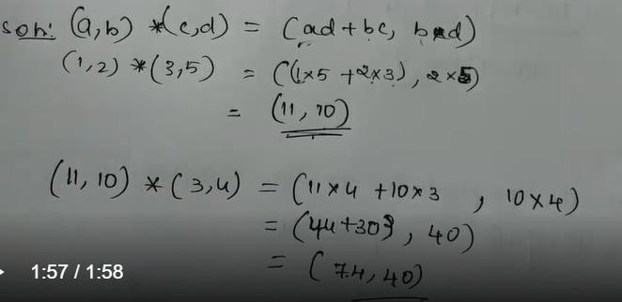

1. An algebraic structure (P,*) is a semi group or not .

Ans- An algebraic structure (P,*) is called a **semigroup** if a*(b*c) = (a*b)*c for all a,b,c belongs to S

1. When a monoid will become a group ?

Ans- A monoid will become a group when their must exist an inverse of each element.

1. if (G,.) is a group such that (ab)-1= a-1b-1 where a& b belongs to G, then G is an ablien group is it true or not .

Ans- True.

1. Matrix multiplication represents which type of property?

Ans- Associative property of multiplication-> A.(BC)=(AB).C

Distributive property of multiplication->A(B+C)=AB+AC (B+C)A=BA+CA

Multiplicative identity property->IA=AI

Multiplicative property of zero->OA=AO

Dimension property: The product of an m\times nm×nm, times, n matrix and an n\times kn×kn, times, k matrix is an m\times km×km, times, k matrix.

1. Is (1,i,-i,-1) set a cyclic group?

Ans- Yes.

1. If A(1,2,3,4) , Let ~={(1,2),(1,3),(4,2)} then ~ is :- Ans- Transitive

1. if (G,+) is a group such that (ab)2= a2b2 where a& b belongs to G, then G is an ablien group is it true or not .

Ans- True

1. The inverse of -i in additive group(1,-1,i,-i) is i or not Ans- True.

1. Is every group is a monoid statement if true or false ?

Ans- True

1. if (G,+) is a group such that (ab)-1= a-1b-1 where a& b belongs to G, then G is not an ablien group Ans- False it is an abelian group.

1. if (G,+) is a group such that (ab)5= a+5b+5 where a& b belongs to G, then G is an ablien group is it true or not .

Ans-

1. A set of all possitive integers under the normal multiplication operator is a group .

Ans- The set of integers under multiplication **is not a group** it does not have the INVERSE

PROPERTY.

1. A set of all possitive integers under the normal multiplication operator for being a group what all properties it must satisfied.

Ans-(A,*) is a group if • A is closed.

* + A is associative.
  + Their exists an identity element(e).
  + Their must be inverse of each element that is a*a^-1=e.

1. How many properties are to be satisfied by an ablien group? Name them .

Ans- Closure Property, Associative Property, Identity Property, Inverse Property, and Commutative Property.

1. if a group dissatisfies the distributive property then can it be considered as a ring ? Ans- No.

1. What all the properties a ring must satisfies to be a field?

Ans- An algebraic structure (A,+,*) is said to be a field if:

(A,+) should be abelian group.

(A,*)-(e) is an abelian group.

1. If n is the smallest possitive integer that satisfies a^n=e. then what is n here ? Ans- n is order.

1. Is set of all integer over the + operator is considered as a monoid. Ans- True.

1. Given set ( 2,4,8,16) what will be the genarator element?

Ans-

1. H*a is a set of which coset?

Ans- Right coset.

1. What is H in an ablien group ?

Ans- Subgroup.

1. Define Generator element with an example.

Ans- In a set A there is an **element g**, such that every other element of the group can be written as a power of g. This element g is the generator of the group.

For example let A={0,1,2,3,4,5)

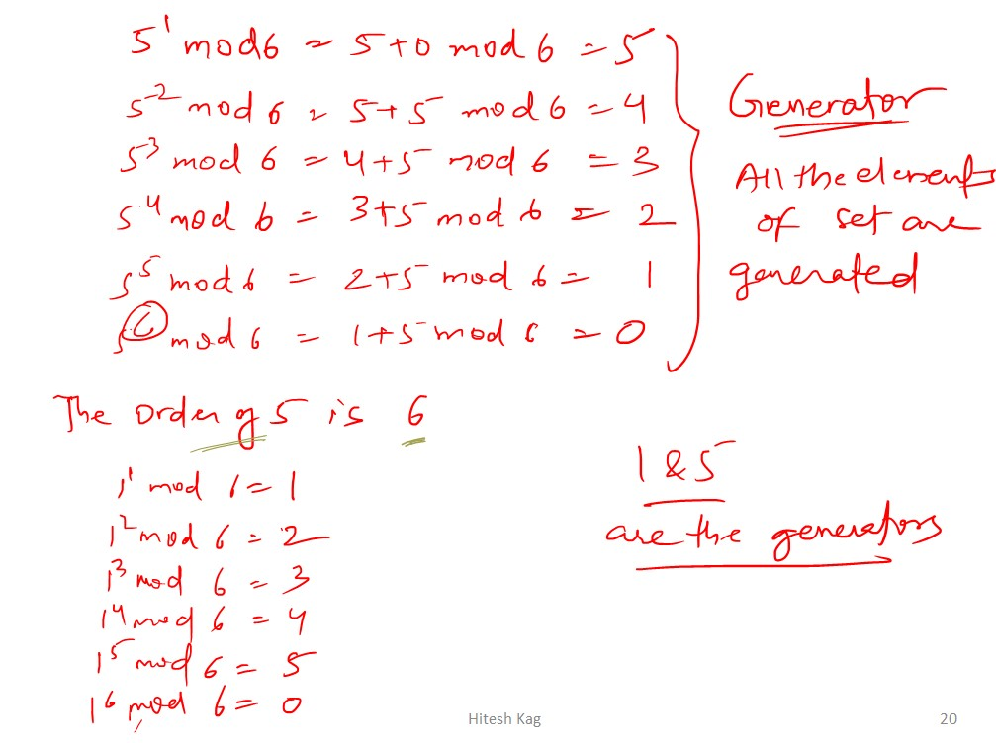

1. Is a set of Z and Zmod n is a cyclic group or not ?

Ans-

1. If a^2= a*a=a is true, then what a represents here?

Ans- ‘a’ is a idempotent.

1. Is a set of natural numbers with + operator can be an ablien group?

Ans- The set of natural numbers under **addition is not a abelian group**, because it does not satisfy all of the group PROPERTIES: it does not have the IDENTITY PROPERTY.

1. Is a set of natural numbers with + operator can be an algebraic structure or not? Ans- Yes it can be considered as an algebraic structure.

1. Is a set of real number satisfing the associative property ?

Ans- Yes

1. Set S( 2,4,6,8.....) set of even number along with the operator + can be a group ? Ans- Yes it can be considered as group.

1. Ring (R,+,*) must satisfies the associative property, state whether it is true or false Ans- False.

1. To be a ring is it mandatory for the relation to be an ablien group?

Ans- True

1. Define idempotent element .

Ans- An element x of a group G is called idempotent **if x** ∗ **x = x**.

1. What do you understand by term closure?

Ans- if a*b €A for all values of a,b €A. Then A is satisfies the closure property.

1. Define Inverse property

Ans- Consider a non-empty set A, and a binary operation * on A. Then the operation is the inverse property, if for each a ∈A,,there exists an element b in A such that a * b (right inverse) = b * a (left inverse) = e, where b is called an inverse of a and e is an identity element.

1. Why a set of odd number along with + operator cannot form an ablien group ?

Ans- Because set of odd number does not satisfy the property of closure that is why set of odd numbers along with + operator cannot form an abelian group.

1. If I b the Identity element and A be any element of the given set and AI=IA , then what is AI? Ans-

1. When a set is considered as a monoid?

Ans- - If an algebraic structure satisfies the associativity and if their exist an identity element (e). That is a*e=a.

For example a*1=a. and a+0=a

1. If in a given group its element's product is also included then what does this statement represents?

Ans-

1. What do you understand by the commutative property?

Ans- For a set A if x*y=y*x then A satisfies the commutative property. Where x,y belongs to A.

1. Why a Set of Natural numbers along with + operator cannot be a group ?

Ans- The set of natural numbers under addition is not a group, **because it does not satisfy all of the group PROPERTIES**: it does not have the IDENTITY PROPERTY

1. Why the set of integers over the operator * is not a group ?

Ans- The set of integers under multiplication is not a group, **because it does not satisfy all of the group PROPERTIES**: it does not have the INVERSE PROPERTY

1. Among the various number system who are eligible to be a valid Ablien group? Ans- Set of real number with + operator.

1. A set of integer , real number and even number along with + operator are eligible to form a valid abilien group ?

Ans- Only the set of real number along with + operator are eligible to form a valid abelian group.

1. A set of Matrix along with * operator is fail to satisfy the inverse property . what does it means

?

Ans- It means that a set of matrix can not be a group.

1. There exist two matrices of order N*N i.e. A and B if we are taking A+B then the resultant matrix is a valid group .

Ans-

1. When a set will considered as a valid group?

Ans- (A,*) is a group if • A is closed.

* + A is associative.
  + Their exists an identity element(e).
  + Their must be inverse of each element that is a*a^-1=e.

1. if AA' = A'A =Iwhere A is the element of a set and A' is its inverse, then what does it represents? Ans- It represents that set satisfies the inverse property.

1. If a set S ( 1,2,3,4,5,6) is satisfying the associative property along with * operator and 30 will be the product of a &b .What is the value of a & b?

Ans- If value of a is 5 then value of b is 6. If value of a is 6 then value of b is 5.

1. If a set S ( 1,2,3,4,5,6) is satisfying the associative property along with * operator. What we will call (3,4)?

Ans-

1. A set S( 2,4,6,8....) with + operator satisfying the condition (2+4)+6= 2+ (4+6), then (2,4,6,8) is considered as :- Ans-

1. A set S( 2,4,6,8.....) with * operator satisfying the condition (2*4)*6= 2* (4*6), then (2,4,6,8) is not considered as semi group why?

Ans-

1. What is Commutative Property is also called?

Ans- This property is also called **the order property of multiplication**. Commutative property only applies to multiplication and addition.

1. What is grouping property of multiplication?

Ans- Associative property.

1. What is associative and distributive properties?

Ans- The **associative property** states that when adding or multiplying, the grouping symbols can be rearranged and it will not affect the result. This is stated as (a+b)+c=a+(b+c)(a+b)+c=a+(b+c). The **distributive property** is a multiplication technique that involves multiplying a number by all of the separate addends of another number. This is stated as a(b+c)=ab+aca(b+c)=ab+ac.

1. Properties of group under group theory.

Ans- (A,*) is a group if • A is closed.

* + A is associative.
  + Their exists an identity element(e).
  + Their must be inverse of each element that is a*a^-1=e.

1. Why group theory is important?

Ans- group theory is **the study of symmetry**. When we are dealing with an object that appears symmetric, group theory can help with the analysis.

1. Where group theory is used in real life?

Ans- Perhaps a most prominent example of an application of group theory (a la symmetry study) in real life is **for the study of crystals**.

1. How Matrices are related to group theory?

Ans- In mathematics, a matrix group is a group G **consisting of invertible matrices over a specified field K, with the operation of matrix multiplication**.

**UNIT – IV**

|  |  |  |
| --- | --- | --- |
| I | Every Isomorphic graph must haverepresen tation. | solved |
| 2 | What is the minimum number of edges needed to generatee the connectivity in a simple graph with 10 vertices? | By the formula n(n-1)/2 E = 45 |
| 3 | What is a chromatic index? | solved |
| 4 | A minimal spanning tree of graph G is | solved |
| 5 | A graph contains 21 edges & 3 vertices of degree 4 & all the other vertices of degree 2. Find out the total number of vertices. | solved |
| 6 | A graph has 24 edges & degree of each vertex is K then which of the following is possible no. Of vertices. | solved |
| 7 | Minimum no. of vertices possible in a simple graph with 41 edges & degree of each vertex is at most 5. |  |
| 8 | How many simple nonisomorphic graph are possible when number of vertices are 3? | solved |
| 9 | How many simple nonisomorphic graph are possible when number of vertices are 5 & edges are 3? |  |
| 10 | Let G be a planar graph with v=10, E=9 & three are components then number of possible regions R are? | solved |
| I l | Maximum number of regions R are possible in a simple planar graph with 10 ed es are? | solved |
| 12 | a simple graph is | A simple graph is a graph that does not have more than one edge between any two vertices and no edge starts and ends at the same vertex |
| 13 | What is the number of edges present in a complete graph having n vertices? | (n*(n-1))/2 |

|  |  |  |
| --- | --- | --- |
| 14 | Vertices with maximal eccentricity is called | The maximum eccentricity from all the vertices is considered as the diameter of the Graph G. The maximum among all the distances between a vertex to all other vertices is considered as the diameter of the Graph G. |
| 15 | A connected planar graph having 6 vertices, 7 edges contains re ions. | By formula e- 2+r It contains 3 regions |
| 16 | If a simple graph G, contains n vertices and m edges, the number of edges in the Graph  G'(Complement of G) is | The union of G and G' would be a complete graph so, the number of edges in G'= number of edges in the complete form of G(nC2)edges in G(m). So (n*n-n-2*m)/2 |
| 17 | A simple graph not hold? | A simple graph maybe connected or disconnected. |
| 18 | What is the maximum number of edges in a bipartite graph having 12 vertices? | solved |
| 19 | What is graph? | a mathematical object consist of a set of 1. V - NODES (VERTICES, POINTS ), 2. E - EDGES BETWEEN PAIR OF NODES |
| 20 | What must be the ideal size of array if the hei t of tree is 'h'? | 2Ah - 1 |
| 21 | What is the parent for a node 'w' of a complete binary tree in an array representation when w is not 0? | Floor of w-1/2 because we can't miss a node |
| 22 | Maximum number of node in complete binary tree of height 5 and root is at hei ht 0. | By formula 2 h -1 So ans is 63 |
| 23 | A connected planar graph having 10 vertices, 15 edges contains how may bounded re ions. | solved |
| 24 | Every Isomorphic graph must haverepresen tation. | adjacency matrix representation |
| 25 | A complete n-node graph Kn is planar if and only if | Any graph with 4 or less vertices is planar, any graph with 8 or less edges is planar and a complete n-node graph Kn is planar if and only if n 4. |
| 26 | A 4- regular graph have 10 edges. The number of vertex in the a h is | solved |
| 27 | If G is simple graph with 15 edges and complement of G has 13 edges then how man vertex in G | solved |

|  |  |  |
| --- | --- | --- |
| 28 | A 3- regular graph have 8 vetex . The number of  Ed es in the a is | solved |
| 29 | A non directed graph contain 16 edges and all vertices are of dgree 2, then the number of vertex in G is | solved |
| 30 | Theof a graph G consists of all vertices and ed es of G. | eulerian circuit |
| 31 | in a graph G is a circuit which consists of every vertex (except first/last vertex) of G exactl once. | Hamiltonian path |
| 32 | A graph with no edges is known as Empty graph. Empty graph is also known as | Empty graph is also known as trivial graphs |
| 33 | A graph G is called a If it is a connected acyclic ra h. | a Tree |
| 34 | In a graph if e=(u,v) means | u is adjacent to v but v is not adjacent to u. |
| 35 | A graph with n vertices will definitely have a parallel edges or self loop if the total number of edges are'? | A graph with n vertices will definitely have a parallel edge or a self loop if the total number of edges are greater than n—l. |
| 36 | A vertex of a graph G is called even or odd de endin u on | the vertex of a graph is called even or odd based on its degree. |
| 37 | A continuous non intersecting curve in the plan whose origin & terminus coincide | jordan graph |
| 38 | A graph with n vertices will definitely have a parallel edge or self loop of the total number of edges are | A graph with n vertices will definitely have a parallel edge or a self loop if the total number of edges are greater than n—l. |
| 39 | The maximum degree of any vertex in a simple graph with n vertices is |  |
| 40 | Circle has | no vetices |
| 41 | A graph is tree if and onl if | A graph is a tree if and only if there is exactly one path between every pair of its vertices |
| 42 | The complete graph with 4 vertices has k de rees where k is | 3 |

|  |  |  |
| --- | --- | --- |
| 43 | Length of the walk of a ra h G is | The total number of edges covered in a walk is called as Length of the Walk. |
| 44 | The number of leaf nodes in a complete binar tree of de th d is |  |
| 45 | An undirected graph possesses an eulerian circuit if and only if it is connected  & it's vertices are | An undirected graph has an Eulerian path if and only if it is connected and has either zero or two vertices with an odd degree. If no vertex has an odd degree, then the graph is Eulerian. |
| 46 | In an undirected graph the number of nodes with odd degree must be | even |
| 47 | Eccentricity of a vertex is denoted by e(v) is defined b | max { d(u,v): u belongs to v, u does not equal to v : where d(u,v) is the distance between u&v) |
| 48 | If some positive integer k, degree of vertex d(v)=k for every vertex v of the graph G, then G is called | K - regular graph |
| 49 | Consider undirected random graph of eight vertices & edges between pair of vertices is 1/2. What is the expected number of unoredered cycles of length three? | solved |
| 50 | Let G be an undirected complete graph on n vertices, where n>2. Then, the number of different  Hamiltonian cycles in ra h G is e ual to | (11-1)! / 2 |
| 51 | In a connected graph, a bridge is an edge whose removal disconnects a graph.  Which of the statements is true? | bridge cannot be part of a simple cycle |
| 52 | An ordered n-tuples  (dl,d2,d3,......dn) and    >=dn is called graphics, if there exists a simple undirected graph with n vertices having degree dl,d2,d3, dn respectively. Which of the following 6tuples is not ra hics? | <3, 3, 3, 1, 0, 0> is not graphic. |

|  |  |  |  |
| --- | --- | --- | --- |
| 53 | A cycle on n vertices is isomorphic to it's complement. The value of n is | 5 |  |
| 54 | Let grapg G=(V,E) be a directed graph where V is set of vertices & E is set of edges. Then which one of the following graph has the same strongly connected components as a h G | G2 = (V, E2) where E2 = | v) I (v, u) e E} |
| 55 | The number of edges in a regular graph of de ree d & n vertices is | nd/2 |  |
| 56 | Let G be a connected planar graph with 10 vertices. If the number of edges on each face is three, then the number of edges in grapg G  is | solved | |
| 57 | A graph is self complementary if it is isomorphic to its complement. For all self complementary graph on n vertices, n is | Congruent to 0 mod 4, or 1 mod 4 | |
| 58 | Consider an undirected graph G where selfloops are not allowed. The vertex set of G is    1<=j<=12}. There is an edge between (a,b) and (c,d) if & lb-  The number of edges in this graph is | 506 | |
| 59 | How many edges will a tree consisting of N nodes have? | In order to have a fully connected tree it must have N-l edges | |
| 60 | If x is a set and the set contains an integer which is neither positive nor negative then the set x is | Set is both Non- empty and Finite. | |
| 61 | graphs are necessarily connected? | no | |
| 62 | What is the minimum number of edges needed to generatee the connectivity in a simple graph with 10 vertices? | MIN edges = n-l  So ans is 9 (doubt) | |

|  |  |  |
| --- | --- | --- |
| 63 | Minimum & Maximum number of edges are necessary in a simple graph with 10 vertices & 3components | The minimum number of edges in any simple connected graph is 'I n-I" for "n" vertices. But here you have 3 components then you need to divide it in 3 parts let it be ICIl=8, IC21=1 and IC3 these are the no. of vertices in the components. So Cl will have 7 edges(i.e. n-l) and other 2 will not have any edges so total 7 edges are here. You can divide the graph in any other way also the result will be same for 3 components.  The maximum number of edges in any simple graph is nC2 so you see larger the value of "n" more the no. of edges. So for 3 components you can take at most 8 vertices in any one component and other 2 have only 1 vertex each and hence 8C2 will give 28 edges in the first component and other two components will have 0 edges. Therefor, there are total 28 edges maximum. |
| 64 | The Graph G be a graph with n vertices & k components. If we del a vertex in graph G then the number of components in graph G should be lie between. | Minimum: The removed vertex itself is a separate connected component.  So removal of a vertex creates k-l components.  Maximum: It may be possible that the removed vertex disconnects all components. For example the removed vertex is center of a star. So removal creates n-l components. |
| 65 | What is chordal? | , a chordal graph is one in which all cycles of four or more vertices have a chord, which is an edge that is not part of the cycle but connects two vertices of the cycle |
| 66 | Spanning trees can be created by removing how many edges from a c cle | by removing maximum e - n + 1 edges, we can construct a spanning tree. |
| 67 | Every Plannar graphs can be colored in at most colors | at most four colors |
| 68 | (l) Every regular graph is Plannar, (Il) Every kRegular graph have euler circuit if k is even | 1. false 2. false |
| 69 | Minimal Cut Set in any complete graph of n vertices have how many |  |
| 70 | Minimal Cut Set in any cycle graph of n vertices have how man ed es |  |
| 71 | Every Isomorphic graph must havereprese ntation. | adjacency matrix representation |
| 72 | A bridge can not be a art of | bridge cannot be part of a cycle |
| 73 | A graph G is calledif it is connected c clic ra h | A graph G is called a Tree if it is a connected acyclic graph |
| 74 | (l) A connected graph cannot have isolated vertex (Il) A disconnected graph should have pendant vertex true or false | l. false 2. true doubt |
| 75 | Maximum degree of a vertex in a cycle of n vertices | In a Cycle Graph, Degree of each vertex in a graph is two |

|  |  |  |
| --- | --- | --- |
| 76 | (l) Every Bipartite graph is tree & Every tree is bipartite graph (Il) If a graph has no cycle then it is bitartite raph | 1. false 2. false |
| 77 | Cut set of a cycle of n vertices can have how man maximum ed es | the maximum number of cut edges possible is I n-I'. |
| 78 | (l) In a graph, all the edges have same edge weights then minimum spanning tree cannot be unique. (Il) Total  Spanning tree of a K4 is  15 | 1. true 2. false |
| 79 | (l) There can be 2 centers in a tree (Il) There can be two centers in cyclic ra h | 1. true 2. |
| 80 | (l) A closed walk can not be cycle. (Il) Euler circuit is a Trail | 1. true 2. true |
| 81 | (l) Bridge can have more than one edge. (Il) Matching number is lagest maximal matchin | 1. true 2.false |
| 82 | A minimal spanning tree of graph G is | A minimum spanning tree or minimum weight spanning tree is a subset of the edges of a connected (un)directed edge-weighted graph that connects all the vertices together, without any cycles and with the minimum total edge weight possible |
| 83 | Consider a weighted undirected graph with positive edge weights and let  (u,v) be an edge in the graph. It is known that the shortest path from source vertex s to u has 53 & shortest path from s to v has weight 65. Which statement is alwa s true | weight (u, v) 2 12 |
| 84 | The complete graph k, hasdifferent s annin trees? | Spanning trees in complete graph is equal to n A (n-2)(where n is no of sides or regularity in complete graph). |
| 85 | n a connected graph, a bridge is an edge whose removal disconnects a graph. Which of the statements is true? | A bridge cannot be part of a simple cycle |
| 86 | A graph is self complementary if it is isomorphic to its complement. For all self complementary graph on n vertices, n is | Congruent to 0 mod 4, or 1 mod 4 |
| 87 | a spanning tree of a graph G? | A spanning tree is a subset of Graph G, which has all the vertices covered with minimum ossible number of ed es. |
| 88 | Consider a complete graph G with 4 vertices. The graph G has s annin trees. | A graph can have many spanning trees. And a complete graph with n vertices has n(n-2) spanning trees. So, the complete graph with 4 vertices |

|  |  |  |
| --- | --- | --- |
|  |  | has 4 A (4-2) = 16 spanning trees. advertisement |
| 89 | The travelling salesman problem can be solved usin | travelling salesman problem can be solved by contracting the minimum spanning tree |
| 90 | Consider a undirected graph G with vertices { A, B, C, D, E}. In graph G, every edge has distinct weight. Edge CD is edge with minimum weight and edge AB is edge with maximum weight. Then, which of the followin is false? | No minimum spanning tree contains AB |
| 91 | it is not the algorithm to find the minimum spanning tree of the iven ra h? | Bellman—Ford algorithm |
| 92 | How many nonisomorphic graphs are possible with 6 vertices and 6 edges and degree of each vertex is 2? |  |
| 93 | Every isomorphic graph must have  re resentation. | adjacency matrix representation |
| 94 | A cycle on n vertices is isomorphic to its complement. What is the value of n? | 5 |
| 95 | How many perfect matchings are there in a complete graph of 10 vertices? | So for n vertices perfect matching will have n/2 edges and there won't be any perfect matching if n is odd. For n=10, we can choose the first edge in  IOC2 = 45 ways, second in 8C2=28 ways, third in 6C2=15 ways and so on. So, the total number of ways 45*28*15*6*1=113400. But perfect matching being a set, order of elements is not important and the permutations 5! of the 5 edges are same only. So, total number of perfect matching is  113400/5! = 945. |
| 96 | A complete n-node graph Kn is a planar if and onl if | Kn is planar if and only if n 4. |
| 97 | A graph isif and only if it does not contain a subgraph homomorphics to K5 or K3,3 | planar graph |
| 98 | An isomorphism of graphs G & H is a bijection if the vertex set of G & H.  Such that any two vertices u & v of graph G are adjacent in graph G if and only if | f(u) and f(v) are adjacent in H |
| 99 | What is the grade of a planar graph consisting of 8 vertices & 15 edges?  Hint:-2*no. Of ed es | If G is a planar graph with n vertices and m edges then r(G) = 2m i.e. the grade or rank of G is equal to the twofold of the number of edges in G. So, the rank of the graph is 2* 15=30 having 8 vertices and 15 edges. |

|  |  |  |  |
| --- | --- | --- | --- |
| 100 | is a graph with no homomorphism to any proper sub ra h. | core | |
| 101 | What is the difference between Graph and  Tree | Root node  Furthermore, one other major difference between tree and graph is that there is a root node in the tree while there are no root nodes in a graph.  Loops  Moreover, the presence of loops is another difference between tree and graph. There are no loops in a tree while there can be loops in a graph.  Complexity  Besides, a graph is more complex than a tree.  Conclusion  Tree and graph are two nonlinear data structures. The main difference between tree and graph is that a tree organizes data in the form of a tree structure in a hierarch while a a h or anizes data as a network. | |
| 102 | Graphs can be  and |  |  |
| 103 | Graphs contains | verices and edges |  |
| 104 | Graphs can be tree but  Tree cannot Graph,  State True or False | false |  |
| 105 | Binary Tree contains two or more child node,  State True or False | false |  |
| 106 | Always, Binary Tree contains two child node,  State True or False | TRUE |  |
| 107 | Sometimes, Binary Tree contains less than two child node, State True or False | TRUE |  |
| 108 | Binary Tree and Binary Search Tree both are different, State True or  False | TRUE |  |
| 109 | With the help of Binary Search Tree, we search particular item. State  True or  False | TRUE |  |
| 110 | If any edge having starting and ending point is same, it is called as | Closed walk |  |
| 111 | If any edges start and end with same pair of vertices then these two edges called as | adjacent | |
| 112 | What is simple graph | a graph in which each edge connects two different vertices and where no two edges connect the same pair of vertices is called as simple graph | |

|  |  |  |
| --- | --- | --- |
| 113 | What is Multi Graph | graphs thay may have multiple edges connecting the same vertices are called multigraph |
|  | What is Finite Graph | A graph with a finite number of nodes and edges |
| 115 | What is Infinite graph | A graph which has either an infinite number of edges or vertices is called an infinite graph. |
| 116 | In a complete graph every vertices is connected to | each vertex is connected to every other vertex of that graph |
| 117 | In a directed complete graph, if no. of vertices is 3 then no of ed es is |  |
| 118 | In a undirected complete graph, if no.  of vertices is 3 then no of ed es is |  |
| 119 | Null graph contains zero edges, State True or False | TRUE |
| 120 | What are the types of sub- ra h | Edge disjoint subgraph and Vertex disjoint subgraph: |

